**HOME AUTOMATION WITH BLUETOOTH**

**1. Introduction**

This project simulates a basic home automation system where an LED is controlled wirelessly using Bluetooth. While real Bluetooth communication isn't supported in Tinkercad, we simulate the functionality using the Serial Monitor. By entering commands like '1' or '0', we can turn the LED ON or OFF, mimicking how a Bluetooth terminal app would interact with an Arduino. This approach demonstrates how wireless control logic works and prepares for implementation on real hardware using modules like HC-05 or ESP32.

**2. Design and Methodology**

The system uses an **Arduino Uno** and an **LED** connected to pin 13. The Serial Monitor in Tinkercad is used to simulate Bluetooth input. The Arduino listens for incoming serial data using Serial.read() and performs actions based on received characters:

* '1' turns the LED ON
* '0' turns the LED OFF

This logic replicates how Bluetooth modules like HC-05 receive data from a mobile app and forward it to the Arduino. The LED's behavior provides immediate feedback, making it easy to understand how command-based control works in embedded systems.

.

**3.components Required**

1. Arduino Uno

2. LED

3. 220Ω resistor

* Serial Monitor (simulated Bluetooth input)

**4.Circuit Design**

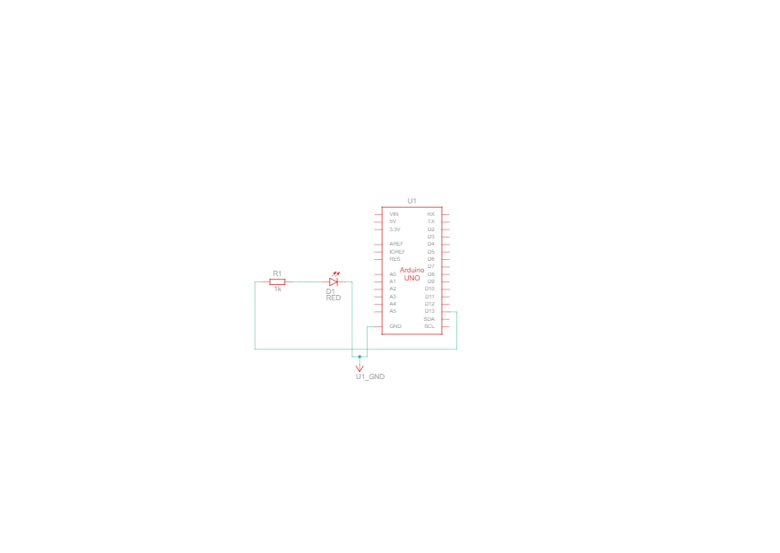

**5.Code**

int serial_bluetooth;

int led=13;

void setup()

{

Serial.begin(9600);

pinMode(LED_BUILTIN, OUTPUT);

}

void loop()

{

if(Serial.available()>0)

{

serial_bluetooth=Serial.read();

if(serial_bluetooth=='1')

{

digitalWrite(led,HIGH);

Serial.println("led on");

}

if(serial_bluetooth=='0')

{

digitalWrite(led,LOW);

Serial.println("led off");

}

}

}

**6. Output Demonstration**

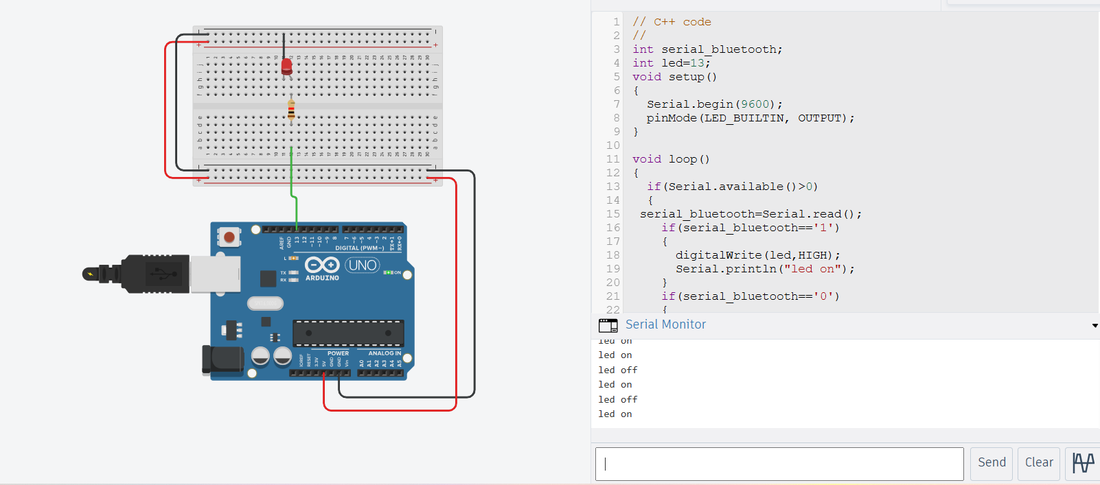

**7.Conlusion**

This project successfully demonstrates how a simple LED can be controlled by simulated Bluetooth commands using Tinkercad’s Serial Monitor. Though it does not use actual wireless communication, the method reflects real-world Bluetooth-based automation systems. It shows how digital devices can respond to external commands, laying a foundation for more advanced home automation projects using real Bluetooth modules or IoT platforms.